"TruthScan: A Fake News Detection System"

A Major Project Report Submitted in Partial Fulfillment of requirements for the Award of Degree of Bachelor of Technology
In
CSE – Artificial Intelligence & Machine Learning

Submitted to



RAJIV GANDHI PROUDYOGIKI VISHWAVIDYALAYA, BHOPAL (M.P)

Submitted By

Sujal Sahu (0537AL231034)
Shubham Chouhan (0537AL231032)

Under the guidance of
Prof. Divya Jain



DEPARTMENT OF ARTIFICIAL INTELLIGENCE & MACHINE LEARNING
Sagar Institute of Science, Technology & RESEARCH, Bhopal

Session: Jan-June 2026

Sagar Institute of Science, Technology & RESEARCH, Bhopal

DEPARTMENT OF ARTIFICIAL INTELLIGENCE & MACHINE LEARNING

CERTIFICATE

This is to certify that the project entitled "TruthScan: A Fake News Detection System" submitted to Rajiv Gandhi Proudyogiki Vishwavidyalaya, Bhopal (M.P.) by the following students:

- Sujal Sahu (0537AL231034)
- Shubham Chouhan (0537AL231032)

is a partial fulfillment of the requirement for the award of degree of Bachelor of Technology in CSE – Artificial Intelligence & Machine Learning. The matter embodied in this report is the actual work done by the above students and is a record of bonafide work done under my supervision.

Prof. Divya Jain Prof. Priyanka Bhatele Dr. Abhishek Choubey
(Guide) (HOD) (Principal)

Sagar Institute of Science, Technology & RESEARCH, Bhopal

DEPARTMENT OF ARTIFICIAL INTELLIGENCE & MACHINE LEARNING

CANDIDATE DECLARATION

We, Sujal Sahu (0537AL231034), Shubham Chouhan (0537AL231032) students of Bachelor of Technology in CSE – Artificial Intelligence & Machine Learning, Sagar Institute of Science, Technology & Research, Bhopal (M.P.), hereby declare that the work presented in this Major Project "TruthScan: A Fake News Detection System" is the outcome of our own work, is bonafide and correct to the best of our knowledge and this work has been carried out taking care of Engineering Ethics. The work presented does not infringe any patented work and has not been submitted to any other university or anywhere else for the award of any degree or any professional diploma.

Date:

- Sujal Sahu (0537AL231034)
- Shubham Chouhan (0537AL231032)

Sagar Institute of Science, Technology & RESEARCH, Bhopal

DEPARTMENT OF ARTIFICIAL INTELLIGENCE & MACHINE LEARNING

APPROVAL CERTIFICATE

This Major Project work entitled "TruthScan: A Fake News Detection System" being submitted by Sujal Sahu (0537AL231034), Shubham Chouhan (0537AL231032),
is approved for the award of degree of Bachelor of Technology in CSE – Artificial Intelligence & Machine Learning.

Internal Examiner External Examiner

Date: Date:

Sagar Institute of Science, Technology & RESEARCH, Bhopal

DEPARTMENT OF ARTIFICIAL INTELLIGENCE & MACHINE LEARNING

ACKNOWLEDGEMENT

We all the project team members find no words to express our deepest sense of gratitude and humble regards to our honourable & esteemed guide Divya Jain Assistant Professor, Department of CSE – Artificial Intelligence & Machine Learning from Sagar Institute of Science Technology & Research Bhopal (M.P.). Under whose regular guidance, constant supervision & inspiring encouragement we have been able to complete this project. His entering help attention & sympathetic attitude left no stone unturned in carrying out the present work.
We express our ardent and earnest gratitude to Prof. Divya Jain for her co-operation, and encouragement at all stages of our work. Their guidance and motivation helped us to be fruitful in our efforts.
We also express our heartfelt and profound gratitude to our Principal, Dr. Abhishek Choubey, for his supports and all the resources provided at all stages of the project work.
Finally, we would like to express that we are deeply indebted to our parents for everything that they have done for us. All of this would have been impossible without their constant support and encouragement.
Lastly, we would like to thank to all those who directly & indirectly helped us during different stages of completion of this project.

- Sujal Sahu (0537AL231034)
- Shubham Chouhan (0537AL231032)

ABSTRACT

TruthScan is an AI-powered verification dashboard designed to eliminate the friction between online news consumption and facts verification. By delivering an enterprise-grade intelligent misinformation detection assistant accessible entirely through a web browser, this project directly supports UN Sustainable Development Goal (SDG) 16 (Peace, Justice, and Strong Institutions). It empowers general news consumers, journalists, and media researchers to maximize informational integrity by automating credibility assessment without requiring users to manually cross-reference sources.

The core backend architecture integrates a custom NLTK-based text preprocessing pipeline for real-time article cleaning, a term frequency-inverse document frequency (TF-IDF) feature extractor (utilizing unigrams, bigrams, and trigrams) for high-dimensional text vectorization, and Scikit-learn machine learning classifiers for predictive modeling. Furthermore, the project advances SDG 9 (Industry, Innovation, and Infrastructure) through its highly optimized cloud deployment strategy. To overcome the compute and storage constraints typical of accessible cloud hosting, the architecture employs a serverless deployment model via Vercel Functions and decoupled cloud-based KVDB storage, promoting sustainable, resource-efficient digital infrastructure. User verification session histories and prediction logs are securely persisted in a remote KVDB cloud database via a resilient, fallback-safe SQLite storage strategy.

The system’s cognitive engine classifies incoming articles into two primary classes: real (empirical news) or fake (sensationalized, deceptive content). For prediction requests, a structured NLP pipeline dynamically removes HTML elements, URLs, and stopwords before executing token lemmatization. A features extraction module transforms preprocessed texts into numerical matrices in real-time; should a classification occur, a custom TF-IDF Explainable AI Algorithm automatically calculates and exposes word-level impact weights. To ensure decision transparency, a two-stage Linguistic Validation indicator override workflow guarantees that sensationalized clickbait words directly influence final model predictions and provide clear, human-interpretable reasoning indicators to the web interface end user.

Deployed entirely on Vercel cloud infrastructure with Python and Flask serving as the central communication hub, end-to-end validation testing confirmed the successful, high-accuracy execution of all core classification workflows. The system demonstrates robust natural language comprehension, effectively processing complex articles in both structured and unstructured text formats.

RELEVANCE TO SDG:

Sr. No. | Sustainable Development Goal (SDG) | SDG Objective | Relevance of the Project | Expected Outcome
1 | SDG 16 – Peace, Justice and Strong Institutions | Promote peaceful and inclusive societies for sustainable development, provide access to justice for all and build effective, accountable and inclusive institutions at all levels, specifically ensuring public access to information. | The project combats the spread of digital misinformation and coordinated disinformation campaigns, which erode public trust in democratic institutions, news media, and civic processes. TruthScan provides an objective verification tool to validate news content. | Preserved integrity of public discourse, strengthened trust in institutional information, and mitigation of polarization caused by fake news.
2 | SDG 9 –Industry, Innovation and Infrastructure | Build resilient infrastructure, promote inclusive and sustainable industrialization and foster innovation. | The system introduces computational innovation in news verification through a hybrid machine learning and natural language processing pipeline. It utilizes optimized serverless microservices and cloud databases to minimize digital carbon footprints. | Scalable, resource-efficient digital auditing infrastructure and deployment of innovative AI applications in media technology.
3 | SDG 4 – Quality Education | Ensure inclusive and equitable quality education and promote lifelong learning opportunities for all, including raising critical media literacy and digital skills among citizens. | By integrating Explainable AI (XAI) features that break down linguistic metrics, structural indicators, and manipulative tactics (e.g., clickbait), TruthScan serves as a learning aid to educate users on critical thinking and news evaluation. | Improved critical thinking, elevated media literacy, and increased public resilience against information manipulation.

TABLE OF CONTENTS

Section | Title | Page No.
Certificate | Certificate | ii
Approval | Approval Certificate | iii
Declaration | Candidate Declaration | iv
Acknowledgement | Acknowledgement | v
Abstract | Abstract | vi
SDG | Relevance to SDG | vii
Chapter 1 | Introduction | 1
1.1 | Overview | 1
1.2 | Problem Statement | 1
1.3 | Objectives | 1
1.4 | Applications | 2
1.5 | Summary | 2
Chapter 2 | Requirement Analysis | 3
2.1 | Team Responsibility Matrix | 3
2.2 | Hardware & Software Interfaces | 4
2.3 | Functional Requirement | 4
2.4 | Non-Functional Requirements | 5
Chapter 3 | Designing & Methodology | 6
3.1 | Overview of Methodology | 6
3.2 | System Architecture | 7
3.3 | Design Diagram | 8
3.3.1 | Flow Chart | 9
3.3.2 | Use Case Diagram | 11
3.3.3 | Class Diagram | 12
3.3.4 | Data Flow Diagram | 13
3.4 | Database Design | 14
3.4.1 | ER Diagram | 14
3.5 | Module Description | 15
3.6 | Algorithm & Workflow | 15
3.6.1 | Algorithm | 16
3.6.2 | Workflow | 17
Chapter 4 | Implementation & Results Analysis | 18
4.1 | Technology Used | 18
4.1.1 | Frontend Implementation | 18
4.1.2 | Backend Implementation | 19
4.1.3 | Testing & Result | 19
4.1.4 | Performance Consideration | 20
4.1.5 | Security Consideration | 21
4.2 | Screenshots with Description | 21
4.2.1 | Home Screen | 22
4.2.2 | Input Page Analysis | 22
4.2.3 | Result & Prediction Card | 23
4.2.4 | Explainable AI Report and History Panel | 24
Chapter 5 | Conclusion & Future Scope | 25
5.1 | Conclusion | 25
5.2 | Limitation | 25
5.3 | Future Enhancement | 26
References | References | 27
User Manual | User Manual | 28

LIST OF FIGURES

S. No | Figure No. | Figure Name | Page No.
1 | Figure 3.1 | System Architecture Diagram | 7
2 | Figure 3.2 | Flow Chart | 9
3 | Figure 3.3 | Use Case Diagram | 11
4 | Figure 3.4 | Class Diagram | 12
5 | Figure 3.5 | Data Flow Diagram (DFD) | 13
6 | Figure 3.6 | Entity Relationship (ER) Diagram | 14
7 | Figure 4.1 | Home Screen | 21
8 | Figure 4.2 | Analysis Input Page | 22
9 | Figure 4.3 | Results & Prediction Card | 23
10 | Figure 4.4 | Explainable AI Report & History Panel | 24

LIST OF TABLES

S. No | Table No. | Table Name | Page No.
1 | Table 2.1 | Team Responsibility Matrix | 3
2 | Table 2.2.1 | Hardware Requirement | 4
3 | Table 4.1.3 | Testing and Results | 20

CHAPTER-1
INTRODUCTION

1.1. OVERVIEW
TRUTHSCAN is an AI-powered verification dashboard and web application developed to provide secure and efficient news analysis services similar to modern fact-checking tools. The system allows users to verify the authenticity of textual content through real-time machine learning predictions, evaluate probability distributions, check dynamic explanation cards, and review recent analysis history in real time. The project was developed to address the growing need for media integrity, misinformation containment, digital verification tools, and critical media literacy.
The application is built using modern web technologies and frameworks such as Python, Flask, SQLite, HTML, CSS, JavaScript, and NLTK. The frontend provides a responsive and user-friendly interface with support for dark and light themes, while the backend manages API routing, text preprocessing, feature extraction, database logging, and model inference. SQLite and cloud-based KVDB storage are used for efficient storage and management of prediction histories, confidence scores, timestamps, and user sessions.
TRUTHSCAN includes several important features such as real-time text analysis, automatic text cleaning and lemmatization, TF-IDF feature extraction, model confidence displays, probability distribution visualization, and detailed Explainable AI reports. Logistic Regression is used for high-accuracy classification and feature coefficient mapping, while Naive Bayes serves as an alternative probabilistic baseline for comparison.
1.2 PROBLEM STATEMENT
The rapid expansion of social media and online news platforms has democratized information dissemination. However, it has also facilitated the viral propagation of misinformation and fake news, which can manipulate public opinion, fuel political polarization, and undermine trust in democratic institutions. Identifying fake news manually is a slow and resource-intensive process that is impractical for the average consumer. Existing commercial verification services are often proprietary, lack transparent explanations (acting as "black-box" models), or are slow to process real-time queries. TRUTHSCAN addresses these needs by providing an open, extensible, and explainable news verification platform that supports real-time text cleaning, classification, feature importance visualization, and history management.
1.3 OBJECTIVE
The main objective of TRUTHSCAN is to develop a secure, scalable, and efficient AI-powered news verification platform that enables users to evaluate and verify the authenticity of news articles in real-time. The system aims to provide seamless article ingestion, rapid text preprocessing, high-accuracy classification, and transparent, explainable feature attribution to build trust with the end user.
1.4 APPLICATION
Primary objectives of TRUTHSCAN are:
- Design a responsive web application for verifying textual articles.
- Implement text preprocessing pipelines including tokenization and lemmatization.
- Integrate TF-IDF feature extraction mapping to model coefficients.
- Provide explanation reports and session history tracking.
- Ensure scalability and reliability for high-volume text analysis.
The platform can be used by news agencies, independent fact-checking groups, and digital media portals where content must be quickly verified before publication. Educational institutions can utilize TRUTHSCAN in media literacy and critical thinking courses to teach students how to identify sensationalist headlines, logical manipulation, and source attribution issues. It can also be integrated into search engines and social media platforms as an API service to flag suspicious content and reduce the spread of unverified claims.
- Digital journalism and editorial newsrooms.
- Educational institutes and media literacy training.
- Social media platforms and comment moderation.
- Independent fact-checking networks and research centers.

1.5 SUMMARY
This chapter introduced TRUTHSCAN, an AI-powered fake news detection system designed to combat digital misinformation. It outlined the project overview, highlighted the integration of Flask, NLTK, and Scikit-learn, and defined the core objectives of the system. The chapter also discussed the critical problem statement of unchecked digital propagation of misinformation and outlined key applications of TRUTHSCAN in journalism, education, and content moderation. The subsequent chapters will detail the system design, dataset attributes, machine learning implementation, and final deployment results.

CHAPTER-2
REQUIREMENT ANALYSIS

2.1 TEAM RESPONSIBILITY MATRIX
Task | Member - 1  Sujal Sahu | Member – 2  Shubham Chouhan
System Architecture & Design | R | I
Requirement Gathering | I | R
Frontend Development (UI/Dashboard) | I | R
Backend API Development (Flask) | R | I
NLP Preprocessing Pipeline | R | R
ML Model Training & Tuning | I | R
Database Design & Management | R | I
Testing & Cloud Deployment | R | R
Project Documentation | I | R

Table 2.1: Team Responsibility Matrix (R = Responsible, I = Informed/Consulted)

2.2 HARDWARE REQUIREMENT & SOFTWARE REQUIREMENT
2.2.1. Hardware Requirement
Table 2.2.1 lists the minimum hardware requirements recommended for local development, model training, and client-side web browser rendering of TruthScan.
Hardware | Minimum Specification
Processor | Intel Core i5 (8th Gen) or AMD Ryzen 5 or equivalent
RAM & Storage | 8GB RAM, 256GB SSD (Solid State Drive)
GPU (Optional) | Integrated Graphics (Dedicated GPU not required for training)

Table 2.2.1: Hardware Requirement

2.2.2 Software Requirement
- Frontend: HTML5, CSS3 (Vanilla CSS for custom layout), JavaScript (Vanilla ES6+)
- Backend: Python (v3.8+), Flask (v2.0+)
- Libraries & Frameworks: NLTK (v3.8+), Scikit-learn (v1.2+), Pandas, NumPy
- Database: SQLite (v3.0+ for local logs), Vercel KVDB (for cloud logging)
- Development Tools: Git, Visual Studio Code (IDE), Postman (API Testing), pip (Package Manager)

2.3 FUNCTIONAL REQUIREMENTS
- Functional requirements describe the core features and operations that the TruthScan Fake News Detection System must perform:
- Article Input Ingestion: Allows users to paste or type plain text news articles into a dedicated input area.
- Character Validation: Real-time character count tracking with visual warning dots (yellow for short text, green for valid length).
- Preset Example Loading: Quick-load buttons for preset "Real News" and "Fake News" examples for rapid system testing.
- Real-Time NLP Preprocessing: Automatic removal of URLs, HTML tags, email addresses, Reuters headers, and stop words, followed by token lemmatization.
- TF-IDF Feature Mapping: Tokenized text conversion into a numerical TF-IDF feature matrix based on n-grams (1 to 3 words) matching 10,000 optimized vocabulary terms.
- Dual-Model Classifier Inference: Execution of optimized machine learning predictions using Logistic Regression and Naive Bayes models.
- Dynamic Confidence Indicator: Display of the classification verdict (Real or Fake) with an SVG-animated circular progress ring representing prediction confidence.
- Probability Distribution: Visual progress bars displaying the split percentage between "Fake News" and "Real News" probabilities.
- Explainable AI (XAI) Output: Identification and extraction of key words contributing to the classification, rendering categorized explanations on Content Analysis, Source Verification, and Manipulation Tactics.
- Analysis History Retrieval: Fetching and listing previous predictions under the same session ID from the SQLite/KVDB database with timestamp formatting.

2.4. NON-FUNCTIONAL REQUIREMENTS
- Non-functional requirements specify the system's quality attributes and operational constraints:
- Low Latency Classification: The model inference and API response should complete in less than 1.5 seconds.
- Aesthetic & Responsive UI: The layout must be fully responsive, scaling seamlessly across mobile, tablet, and desktop viewports with dynamic dark/light mode support.
- Cross-Browser Compatibility: The system must render and function correctly across major web browsers (Chrome, Safari, Firefox, Edge).
- Graceful Database Fallbacks: The API must continue executing classifications locally (using custom indicator lists and local SQLite database fallbacks) if remote KVDB databases or final model pickles are unavailable.
- Robust Input Validation: The system must reject empty inputs or articles shorter than 10 characters, displaying error toast notifications to prevent model bias.
- Secure Session Isolation: Recent history records must be isolated to individual users utilizing randomized session tokens to preserve privacy.
- Scalability & High Availability: The application must maintain operational uptime when deployed as serverless functions (e.g., on Vercel or Render).
- Model Portability: Trained models and vectorizers must be serialized securely as lightweight pickle (.pkl) binaries for rapid memory allocation on startup.

CHAPTER-3
DESIGNING & METHODOLOGY

3.1. METHODOLOGY OVERVIEW
The development of TRUTHSCAN followed a systematic and structured methodology to ensure successful implementation of the machine learning-based fake news detection platform. The project was developed using the Software Development Life Cycle (SDLC) approach, which includes planning, analysis, design, development, testing, deployment, and maintenance phases. This methodology helped in organizing the project workflow efficiently and ensured proper coordination between frontend, backend, database, and machine learning modules.

- In the initial phase, project requirements were gathered and analyzed to understand the core functionalities required in the system such as text ingestion, natural language cleaning pipelines, TF-IDF vectorization, ML classification, explainable AI explanations, and session logging. After requirement analysis, the system architecture and database design were prepared to define the interaction between different system components and data flow within the application.

- During the design phase, user interface layouts, UML diagrams, flowcharts, ER diagrams, DFDs, and system architecture diagrams were created to visualize the structure and working of the system. The frontend was developed using HTML5, CSS3, and JavaScript to build responsive and interactive user interfaces. The backend API was developed using Python and Flask to manage model requests, log analysis histories, and handle database persistence.

- During the development phase, the machine learning pipeline was implemented using Python's Scikit-learn library. The ISOT dataset consisting of 44,898 real-world news articles was loaded, cleaned, and preprocessed using the NLTK text processing module. The TF-IDF vectorizer was configured with unigram, bigram, and trigram features across a 10,000-term vocabulary. Logistic Regression and Naive Bayes classifiers were trained and evaluated using GridSearchCV with 3-fold cross-validation to optimize hyperparameters and select the best-performing model.

3.2. SYSTEM ARCHITECTURE
The architecture of TRUTHSCAN is designed using a client-server model integrated with machine learning models and serverless database integrations to provide secure, low-latency, and accurate news verification services.
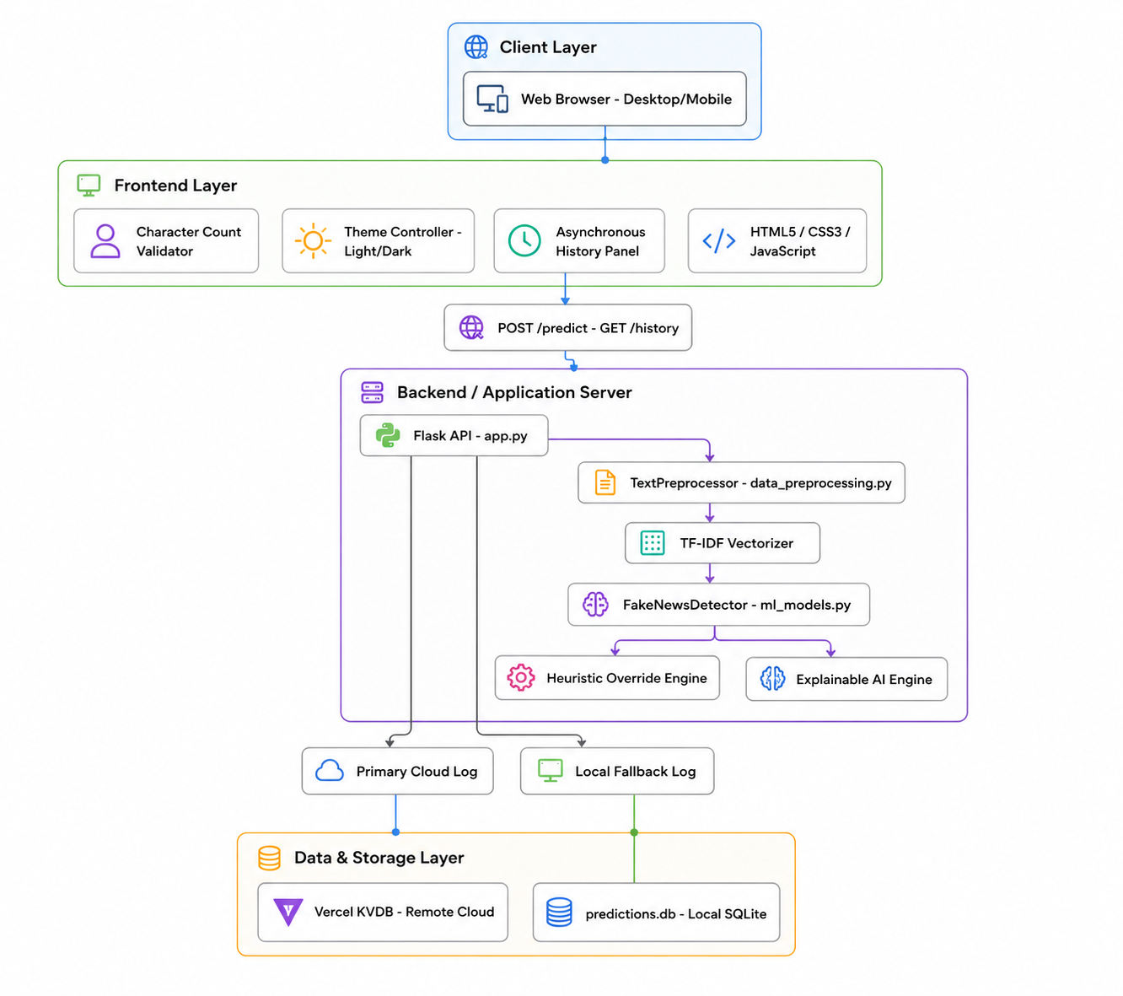

Fig. System Architecture Diagram

Architecture Explanation:
- Client / User Layer: Users access the TRUTHSCAN dashboard through web browsers on various devices (desktops, laptops, tablets, or mobile phones) where they can input text and view predictions.
- Frontend Layer: Built using HTML5, CSS3, and JavaScript, it manages UI rendering, responsive layouts, character limits, example loading, and asynchronous calls to the backend via Fetch APIs.
- Backend / Application Server: Powered by Python and Flask, it handles API routing, coordinates the execution of text processing pipelines, extracts features, loads serialized model pickles, and coordinates database operations.
- Machine Learning & NLP Module: Handles raw text preprocessing (tokenization, stop word removal, and lemmatization) via NLTK, applies TF-IDF vectorization, performs classification, executes override checks, and calculates word-level feature weights.
- Data & Storage Layer: Manages persistence by storing user session IDs, timestamps, inputs, and verdicts in Vercel KVDB (remote key-value cloud store) with a local SQLite database (predictions.db) fallback.

3.3. DESIGN DIAGRAMS
3.3.1. Flow Chart
The flow chart of TRUTHSCAN represents the complete working process of the news verification system from user text input to result rendering and history updates.
A user submits a news article through the web interface, where the input is first validated. The system validates the input and rejects text shorter than 10 characters with an error message. The text is then preprocessed by removing unnecessary content like HTML tags, URLs, stop words, and applying lemmatization. Next, TF-IDF vectorization converts the text into numerical features, which are analyzed by a Logistic Regression model to classify the news as Real or Fake.
The system further evaluates linguistic indicators and generates Explainable AI (XAI) insights to justify the prediction. The final verdict, confidence score, and explanation are stored in KVDB/SQLite and returned to the frontend. The dashboard and history panel are updated dynamically, allowing users to view both current results and previous predictions without refreshing the page.

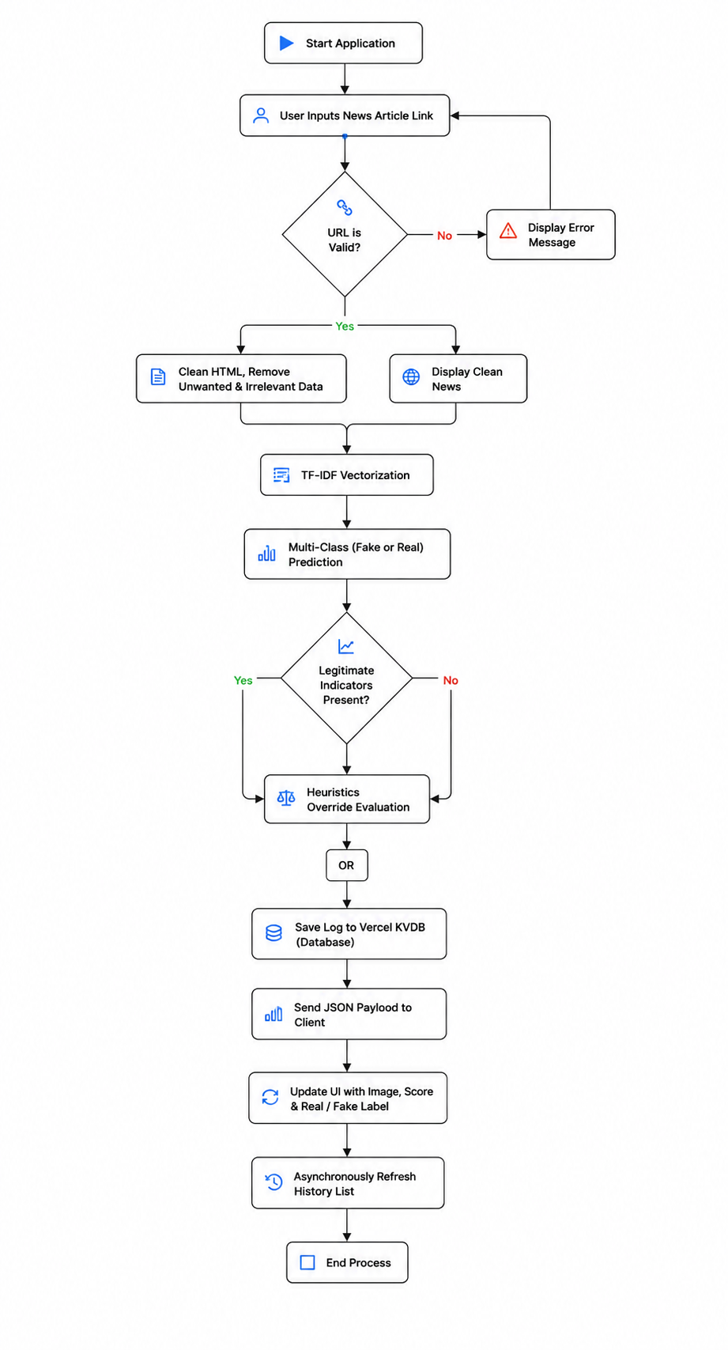
Fig. Flow Chart

1. User Request & Validation Flow
The process begins when the user submits text via the Web Interface.
- If the text is shorter than 10 characters, the system rejects it and triggers an error toast.
- If valid, a fetch request containing the text and session ID is dispatched to the /predict route.
2. NLP & Model Inference Flow
- The backend cleans the text (removing HTML, URLs, stop words) and lemmatizes tokens.
- The TF-IDF vectorizer transforms tokens into a 10,000-dimensional matrix.
- The Logistic Regression model runs classification, calculates class probabilities, and applies indicator adjustments.
The Explainable AI module extracts feature weights.
3. Data Logging Flow
- The backend generates an IST timestamp.
- It logs the session ID, timestamp, original text, verdict, and confidence to KVDB/SQLite.
- The backend returns a JSON response containing class predictions, probabilities, and XAI explanations to the frontend.
4. Result Rendering Flow
The frontend receives the JSON response and dynamically updates the results dashboard.
- The SVG circular progress ring animates to reflect the confidence percentage score.
- The probability distribution bars for Fake News and Real News slide to their respective widths.
- The XAI explanation is parsed from markdown and rendered as structured HTML inside the analysis card.

5. History Management Flow The frontend asynchronously dispatches a GET request to the /history route using the session ID.
- The server queries the KVDB cloud store or SQLite database for all records linked to the current session.
- Records are sorted chronologically by timestamp and filtered for duplicates before returning.
- The history panel is updated with verdict badges, confidence scores, and IST timestamps without reloading the page.
3.3.2. Use Case
The primary actor in the system is the User (Reader/Journalist), who can paste articles, load examples, analyze text, toggle UI themes, and view their session history. The Administrator actor manages system-level operations, including database optimization, model retraining, evaluating accuracy reports, and monitoring system usage logs.

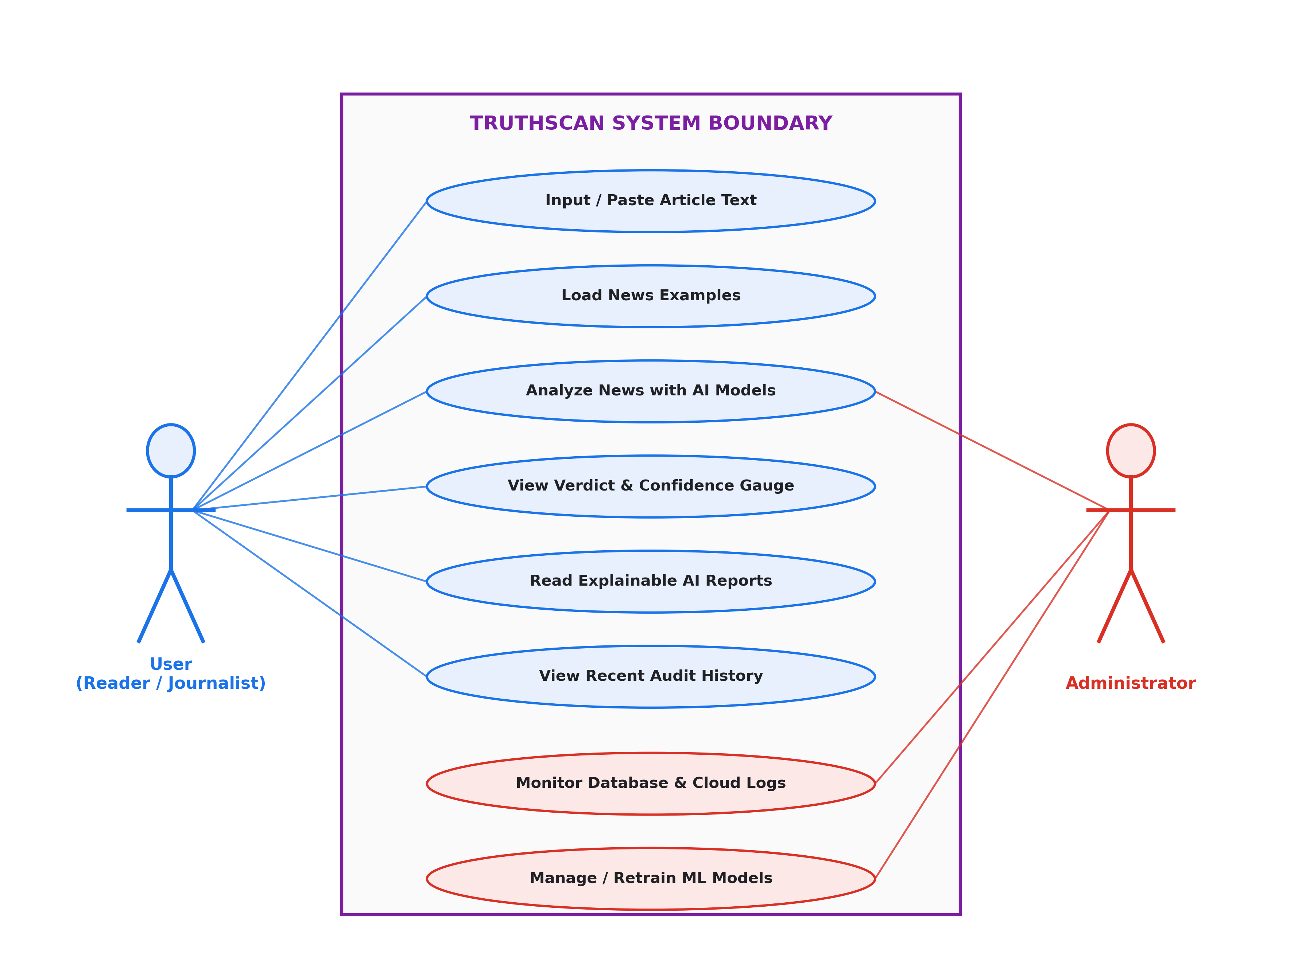
Fig. Use Case

3.3.3. Class Diagram
It helps in understanding how various classes and modules in the application interact to perform functionalities such as text preprocessing, classification, database logging, and API rendering. The class diagram follows the object-oriented programming approach and acts as a blueprint for the development of the application
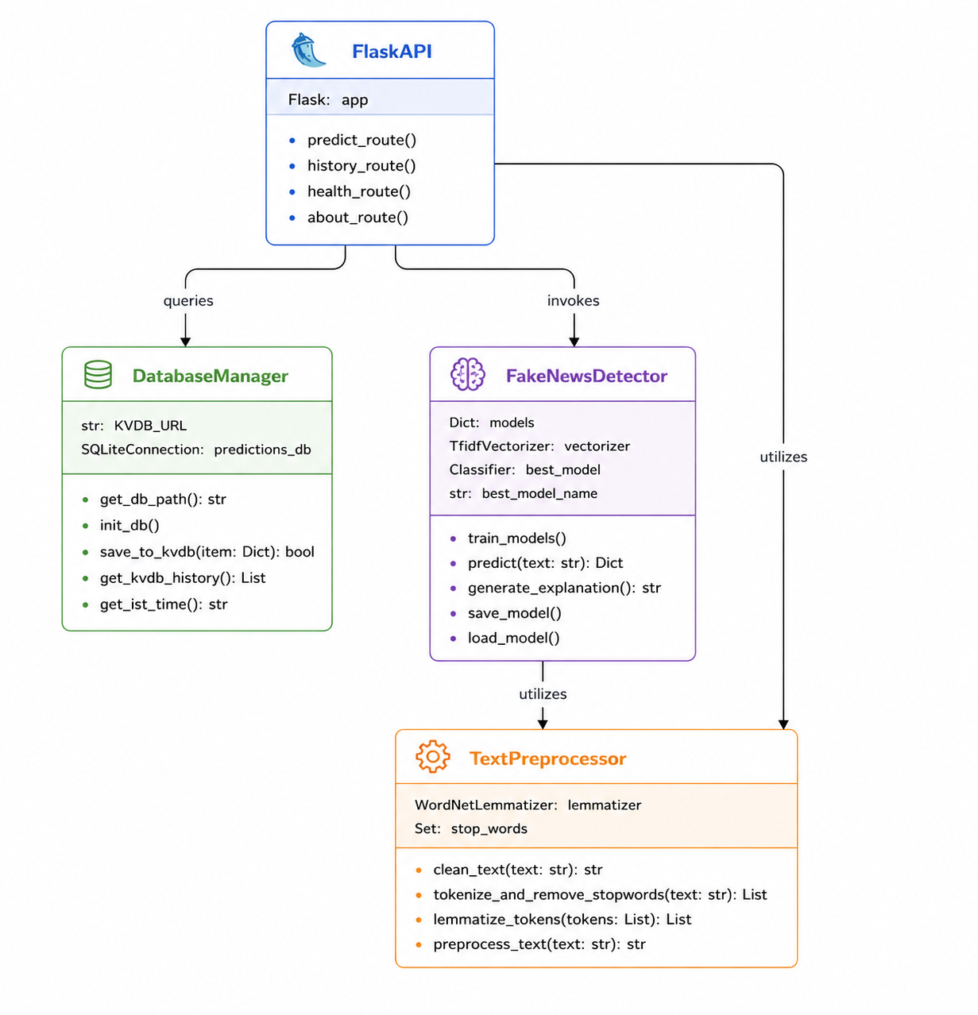

Fig. Class Diagram

3.3.4. Data Flow Diagram (DFD)
The Data Flow Diagram represents the logical flow of data through the TruthScan system, illustrating how user inputs are transformed by NLP processes and machine learning models before being logged in the database and returned to the UI.

- Level-0 DFD (Context Diagram)
Shows the overall system boundary, the single external entity (User), and the core input/output data flows:
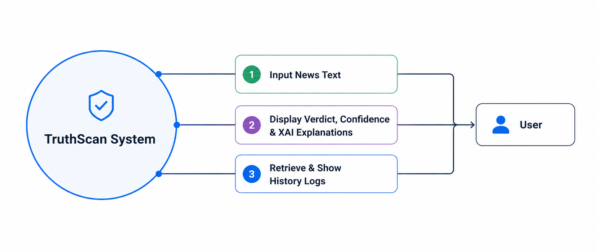
Fig. Context Diagram
- Level-1 DFD (Process Decomposition)
Decomposes the system into its core functional processes, data stores, and entity interaction flows:
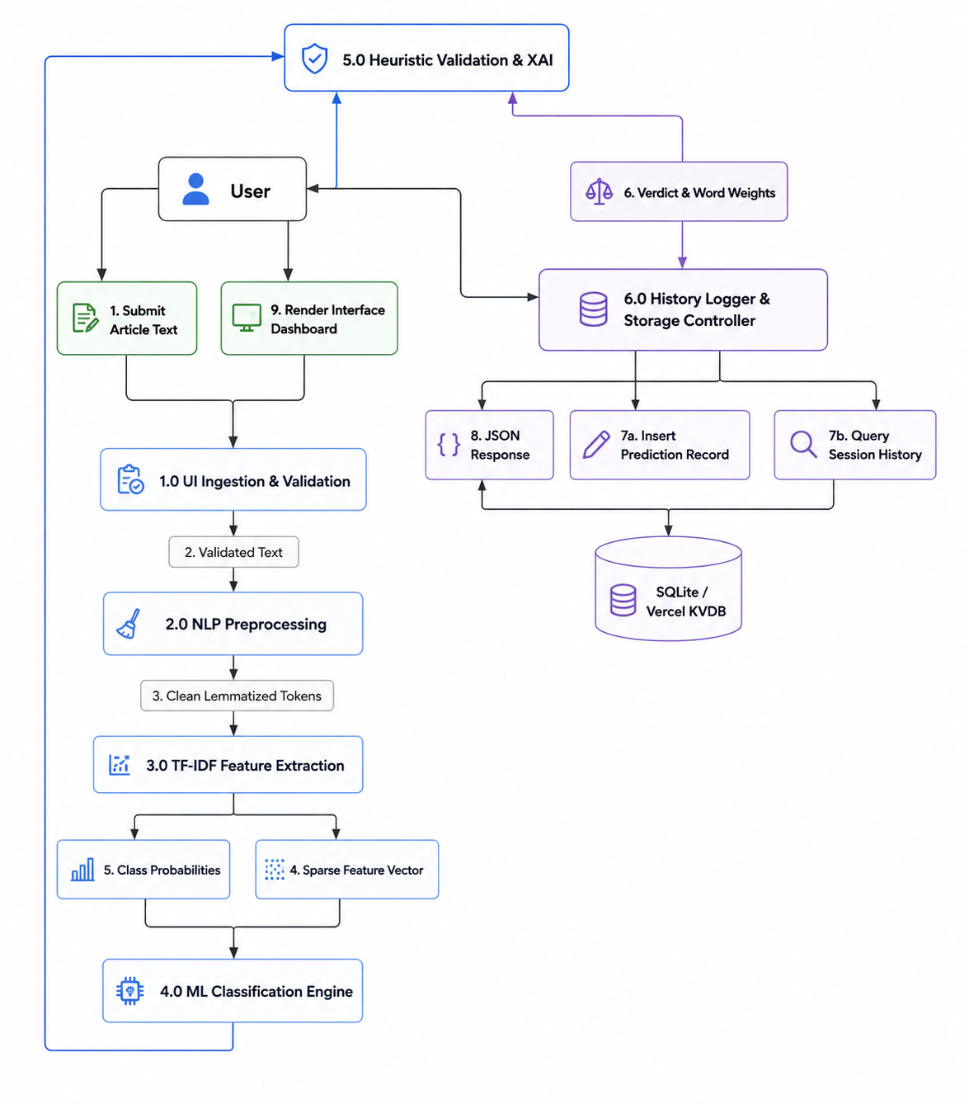
Fig. Process Decomposition
3.4 DATABASE DESIGN
The database design for TruthScan is optimized for recording predictions asynchronously, supporting session isolation, and enabling rapid retrieval of historical news audits.
3.4.1. ER Diagram
The Entity-Relationship (ER) diagram for TruthScan showcases a streamlined database schema designed to track news evaluation history. It uses a single primary entity, History, linked logically to user session identifiers.
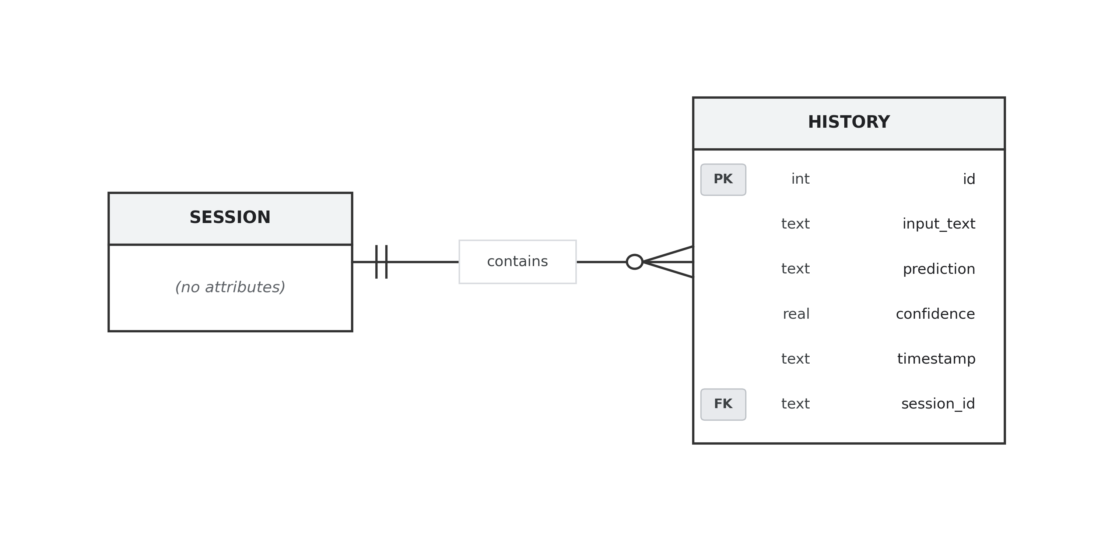
Fig. ER Diagram

History Table Schema Details:
- id (Integer, Primary Key): A unique, auto-incrementing integer identifier for each database record.
- input_text (Text): The original textual content submitted by the user.
- prediction (Text): The final classification verdict assigned by the system (Real News or Fake News).
- confidence (Real): The model's probability score for the predicted class (bounded between 0.0 and 1.0).
- timestamp (Text): The date and time of analysis formatted to Indian Standard Time (IST).
- session_id (Text, Foreign Key): A unique identifier generated on the client side to retrieve history logs specific to a user's browser session.

3.5 MODULE DESCRIPTION
TruthScan is divided into seven core modules that interact seamlessly to deliver real-time news classification:
- User Interface & Dashboard Module: Manages the responsive frontend interface (HTML5/CSS3/JavaScript). It controls the dark/light theme toggle, handles example loader presets, runs character validation, and updates the radial confidence rings.
- Session & History Management Module: Generates randomized, session-persistent browser tokens (session_id) and executes asynchronous HTTP requests to /history to populate and refresh user history lists without reloading the page.
- Text Preprocessing & Cleaning Module: Leverages the NLTK library to clean raw inputs. It utilizes regular expressions to strip HTML tags, URLs, email addresses, Reuters headers, and numbers before tokenizing, removing stop words, and lemmatizing words to their root forms.
- TF-IDF Feature Extraction Module: Employs a pre-fit TF-IDF Vectorizer mapping n-grams (range 1-3) up to 10,000 dimensions to transform preprocessed text strings into sparse numerical feature matrices.
- Machine Learning Classification Module: The core model inference system. It loads trained Logistic Regression and Multinomial Naive Bayes models from pickles, calculates prediction probabilities, and defaults to a backup heuristic keyword classifier if binary models fail to load.
- Heuristic Override & Validation Module: Applies post-inference checks. It scans the input for strong, highly-polarized contextual indicator keywords (e.g., "conspiracy", "doctors hate", "peer-reviewed") and recalibrates model confidence scores to suppress false positives/negatives.
- Explainable AI (XAI) & Report Generation Module: Evaluates the active components of the input text vector against model coefficients (coefficient or feature log-probabilities) to calculate word-level influence scores, dynamically outputting a human-readable text explanation dividing content analysis, source verification, and manipulation tactics.

3.6 ALGORITHMS & WORKFLOW
3.6.1. Algorithm of TruthScan
Step 1: Input Ingestion & Validation
- Start the application backend (Flask) and open the browser dashboard.
- User inputs or pastes an article text block into the dashboard.
- The frontend validates that the text is at least 10 characters long.
- If valid, the client sends a POST request to /predict containing the text and session_id.
- If invalid, the system displays an error toast and halts.

Step 2: NLP Preprocessing
- Remove HTML tags, hyperlinks, and contact details.
- Strip Reuters metadata prefixes and lowercase the text.
- Tokenize the text into individual word units.
- Eliminate common stop words.
- Lemmatize remaining tokens to their base form.
Step 3: Feature Extraction
- Retrieve the preprocessed text string.
- Load the pre-trained final_vectorizer.pkl.
- Apply TF-IDF vectorization to convert the text to a sparse feature vector of 10,000 dimensions.
Step 4: Machine Learning Inference
- Load the pre-trained final_model.pkl (Logistic Regression).
- Feed the TF-IDF feature vector to the classifier.
- Compute predictions (0 for Fake News, 1 for Real News) and their raw class probabilities.
Step 5: Heuristic Adjustment & Explainable AI (XAI)
- Scan text for specialized indicator lists.
- Adjust the prediction probabilities if strong linguistic indicators override the model.
- Map vector indices back to model coefficients to determine word weights.
- Construct a structured explanation detailing Content, Source, and Tactic indicators.
Step 6: Session Logging & Data Persistence
- Determine the hosting environment.
- If hosted on Vercel, push the prediction log (Text, Verdict, Confidence, Session ID, Timestamp) to Vercel KVDB.
- Save the log locally to predictions.db using SQLite as a secondary fallback.
Step 7: Results Rendering
- Deliver the JSON payload back to the client.
- Update the radial confidence ring, verdict labels, and probability progress bars.
- Render the formatted XAI report.
- Reload the session history panel asynchronously.
- End process.

3.6.2. Workflow
The workflow of TRUTHSCAN begins when a user accesses the application through a web browser. The system initializes a unique, session-persistent identifier (session_id) in browser storage to track the current user's queries securely. Upon reaching the dashboard, the user is presented with a text input box where they can paste a news article or load pre-populated examples.
When the user submits the article for analysis, the JavaScript frontend validates the character count and triggers an asynchronous API call to the Flask backend server. The backend receives the payload and directs it to the NLP Preprocessing module, which removes stylistic artifacts, metadata prefixes, and stop words, reducing the text to a clean list of base lemmas. This cleaned string is transformed into a high-dimensional sparse array by the TF-IDF Vectorization module.
This feature vector is evaluated by the Logistic Regression classifier. Before delivering the result, the system runs an override check to catch highly polarized clickbait words or peer-reviewed terms, recalibrating the final probability. Simultaneously, the Explainable AI (XAI) engine correlates active features with classifier weights to identify which words had the most significant impact on the decision, generating a structured report.
Once classification is complete, the backend records the text, verdict, confidence, session ID, and timestamp into the SQLite/KVDB database to update the history. Finally, the server returns a JSON payload containing the prediction results, class probabilities, and explanation details. The frontend dynamically renders this data as an interactive circular progress gauge, probability sliders, and an explainable markdown card, while asynchronously updating the recent analysis history list.

CHAPTER-4
IMPLEMENTATION & RESULT ANALYSIS

4.1. TECHNOLOGIES USED
- Frontend Technologies: HTML5 – Structure and layout of web pages, CSS3 – Styling, animations, and responsive design, JavaScript (ES6+) – Client-side functionality and DOM manipulation.

- Backend Technologies: Python (v3.8+) – Core programming language for backend logic, Flask (v2.0+) – Lightweight backend framework for API routing and server management.

- Machine Learning & NLP: Scikit-learn – Machine learning model training, evaluation, and inference, NLTK – Natural language processing and text preprocessing pipeline, Pandas & NumPy – Dataset loading, manipulation, and numerical operations.

- Database: SQLite – Local relational database for storing prediction history, Vercel KVDB – Cloud-based key-value store for remote session persistence.

- Deployment & Tools: Vercel – Serverless cloud deployment platform, Git – Version control and source code management, Visual Studio Code – Primary development IDE, Postman – API endpoint testing and validation, Pickle – Model serialization for saving and loading trained classifiers.

4.1.1. FRONTEND IMPLEMENTATION
The frontend of TRUTHSCAN was developed using modern web technologies to create an interactive, responsive, and user-friendly interface for real-time news verification. Technologies such as HTML5, CSS3, and JavaScript were used to design the application interface and improve user experience. The frontend includes several important sections such as the hero landing page, the article input analysis card, the results verdict panel, the probability distribution bars, the Explainable AI report card, and the session history panel.
The interface supports both dark and light themes, toggled via a button that stores the preference in browser local storage for persistence across sessions. A unique session token is generated on page load using JavaScript and stored in session storage to isolate each user's prediction history. The character count indicator updates in real time and changes color to guide users toward valid input lengths. Example article presets (Fake and Real) allow users to quickly test system behavior without manually entering text. All API communications between the frontend and Flask backend are handled asynchronously using the Fetch API, ensuring the page remains responsive and never requires a full reload.

4.1.2. BACKEND IMPLEMENTATION
The backend of TRUTHSCAN was developed using Python and Flask to manage server-side operations, API routing, machine learning inference, and database persistence. SQLite was used as the local database system to store prediction records including input text, classification verdict, confidence score, session ID, and IST-formatted timestamps, while Vercel KVDB was integrated as the primary cloud storage solution for remote session history retrieval.
The NLTK library was integrated into the preprocessing pipeline to perform sequential text cleaning operations including HTML tag removal, URL stripping, stop word elimination, tokenization, and WordNet lemmatization. The Scikit-learn TF-IDF vectorizer and Logistic Regression classifier were trained on the 44,898-article ISOT dataset and saved as serialized pickle binaries for fast memory loading on application startup.
A heuristic override engine was implemented to recalibrate model confidence scores when strong linguistic indicators are detected in the input text. The Explainable AI module maps active TF-IDF feature indices to model coefficients to generate structured word-level influence reports. RESTful API endpoints were developed to manage text prediction, session history retrieval, and system health monitoring. Various backend resilience mechanisms such as KVDB fallback switching, SQLite timeout handling, and structured error responses were implemented to ensure reliable and consistent system performance.

4.1.3. TESTING AND RESULTS
During development, the system was tested locally and on the Vercel cloud platform across multiple browser environments. Each core feature was individually validated to confirm correct functionality, accurate responses, and proper error handling behavior.

Test Scenario | Expected Result | Status
Article Text Submission | Prediction returned with verdict and confidence | Passed
Short Text Rejection (<10 chars) | Error toast displayed, request blocked | Passed
NLP Preprocessing Pipeline | Clean lemmatized tokens produced correctly | Passed
TF-IDF Vectorization | 10,000-dimensional sparse matrix generated | Passed
Logistic Regression Classification | Correct Real/Fake verdict returned | Passed
Heuristic Override Adjustment | Confidence recalibrated on indicator detection | Passed
XAI Report Generation | Word weights extracted and explanation rendered | Passed
KVDB Cloud Logging | Prediction record saved to cloud store | Passed
SQLite Fallback Logging | Record saved locally on KVDB failure | Passed
Session History Retrieval | Last 50 records returned for session ID | Passed
Dark / Light Theme Toggle | Theme switches and persists across sessions | Passed
Example Preset Loading | Article preloaded into text area correctly | Passed
Table 4.1.3: Testing and Results

4.1.4. PERFORMANCE CONSIDERATIONS
TRUTHSCAN uses a serialized Logistic Regression model loaded directly into memory at startup to eliminate per-request disk I/O overhead and minimize API response latency. The TF-IDF vectorizer is pre-fitted and cached in memory, ensuring that feature extraction completes in milliseconds. For high-volume deployment scenarios, it is recommended to implement a model serving layer using tools such as Gunicorn with multiple worker processes to handle concurrent prediction requests efficiently. Asynchronous JavaScript fetch calls prevent UI blocking during API processing. For production deployments expecting large prediction volumes, migrating from SQLite to a scalable relational database such as PostgreSQL is recommended to handle concurrent write operations without locking issues.

4.1.5. SECURITY CONSIDERATIONS
Security measures implemented and recommended for TRUTHSCAN:
- Use HTTPS for all client-server communication to encrypt API payloads containing user-submitted text.
- Session tokens are generated using randomized alphanumeric strings combined with timestamps to prevent session hijacking or enumeration attacks.
- All user-submitted text is sanitized server-side before being stored in the database to prevent SQL injection attempts.
- Environment variables are used to store sensitive credentials such as KVDB authentication tokens, keeping them out of the source code repository.
- Cache-control headers (no-store, no-cache) are applied to all history API responses to prevent sensitive prediction records from being stored in browser or proxy caches.
- Input length validation is enforced on both the client side (JavaScript) and server side (Flask) to prevent oversized payload attacks.

4.2. SCREENSHOTS OF WEB APPLICATION
4.2.1. HOME SCREEN
The Home Screen of TRUTHSCAN serves as the primary landing page of the application. It features a full-width hero section with the system title, a descriptive tagline, and two call-to-action buttons directing users to the analysis section and the How It Works guide. A floating analytics dashboard widget on the right side of the hero displays key system statistics including the total number of training articles (44,898), overall model accuracy (99.4%), and a dataset distribution bar chart illustrating the proportion of fake and real news articles. The navigation bar at the top provides smooth-scroll links to the Analyze, Features, and How It Works sections, along with a dark/light theme toggle button. The background features animated gradient orb effects and a subtle grid pattern to create a modern, visually premium aesthetic.
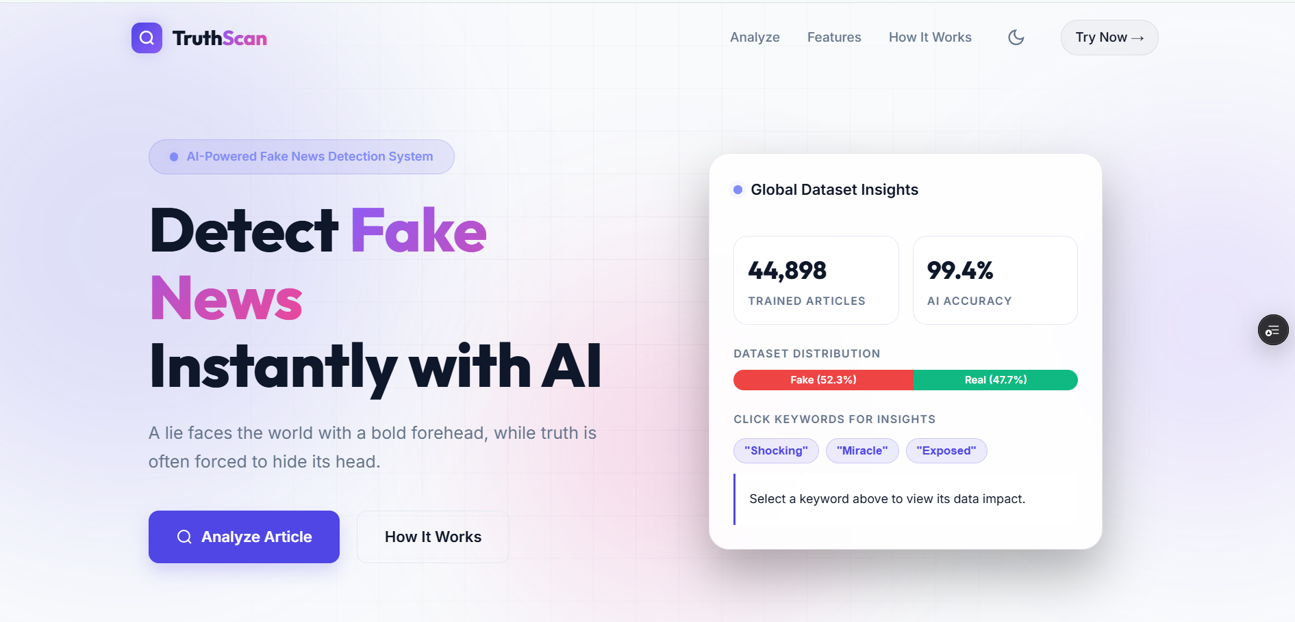
Fig. Home Screen
4.2.2. ANALYSIS INPUT PAGE
The Analysis Input Page is the core functional interface of TRUTHSCAN where users submit articles for verification. It contains a prominently displayed text area with a real-time character counter and a color-coded validation dot that transitions from gray (empty) to orange (too short) to green (valid). Below the text area, two quick-load example buttons allow users to instantly populate the field with a preset Fake News or Real News sample article. A large gradient "Analyze with AI" submit button triggers the prediction pipeline. While the API processes the request, the button transitions to a loading state with a spinner animation, and a skeleton loading card appears below to indicate that the analysis is in progress.

Fig. Input Page

4.2.3. RESULTS & PREDICTION CARD
The Results and Prediction Card is displayed immediately below the input form after the AI analysis completes. It presents the classification verdict (REAL NEWS or FAKE NEWS) in large, color-coded bold text (green for real, red for fake) alongside a verdict icon. An animated SVG circular progress ring on the right side of the card fills to the model's confidence percentage, providing an immediate visual confidence indicator. Below the verdict section, two animated horizontal probability bars display the exact percentage split between the Fake News and Real News probability scores. The results card uses a glassmorphic card design with a colored glow shadow that changes color based on the verdict type, making the classification outcome immediately recognizable at a glance.

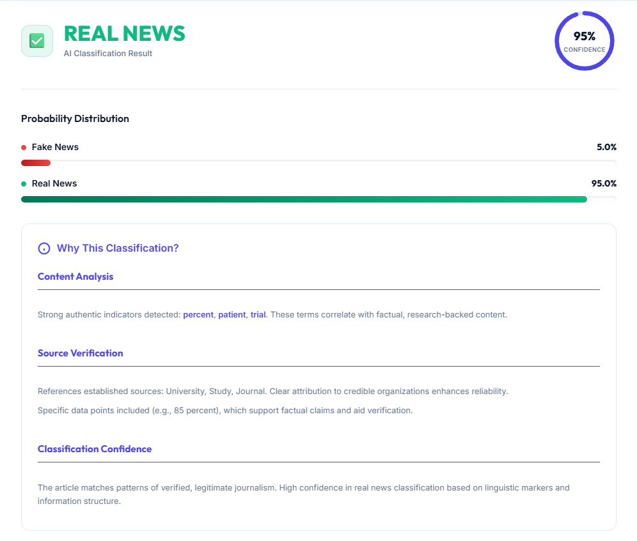
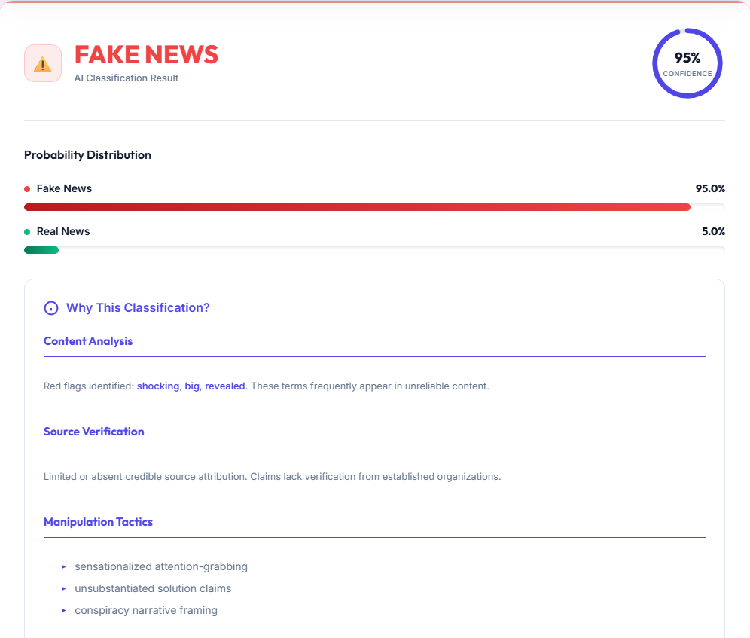
Fig. Results Card (Real or Fake News)
4.2.4. EXPLAINABLE AI REPORT & HISTORY PANEL
The Explainable AI Report and History Panel feature enables users to understand the reasoning behind each classification verdict. The XAI report card is rendered directly beneath the results card and is divided into three structured sections: Content Analysis (highlighting the most influential keywords detected), Source Verification (evaluating institutional references and data citations), and Manipulation Tactics (listing detected sensationalist language patterns such as clickbait terminology and conspiracy framing). Key words are highlighted in bold and color-coded to distinguish authentic indicators from fake news markers. Below the XAI card, the Recent Analysis History panel displays a scrollable list of the user's previous predictions for the current session, showing each article's truncated text, classification badge, confidence score, and IST timestamp. Users can refresh the history panel at any time using the Refresh History button.

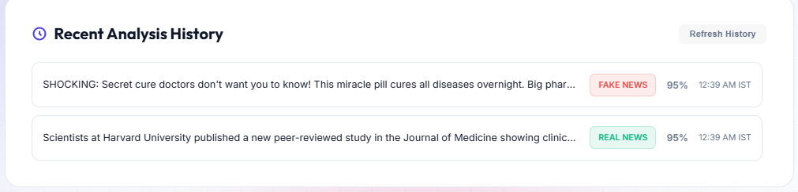
Fig. History Page

CHAPTER-5
CONCLUSION & FUTURE SCOPE

5.1 CONCLUSION
TRUTHSCAN is an AI-powered fake news detection and verification platform developed to provide accurate, explainable, and real-time news authenticity analysis accessible through a modern web browser. The project successfully integrates various technologies such as HTML5, CSS3, JavaScript, Python, Flask, NLTK, Scikit-learn, SQLite, and Vercel KVDB to deliver functionalities including text preprocessing, TF-IDF feature extraction, machine learning classification, Explainable AI reporting, session-based history tracking, and cloud-based data persistence.
The system was designed using a modular and scalable architecture that ensures smooth interaction between the frontend interface, backend API routing layer, NLP preprocessing pipeline, machine learning inference engine, and database logging modules. Security mechanisms such as session token isolation, environment variable protection, input sanitization, and cache-control headers were implemented to provide secure data handling and user privacy protection. SQLite was used for efficient local data storage and management, while Vercel KVDB enabled resilient cloud-based session history persistence with an automatic fallback strategy.
Extensive testing and performance optimization were carried out to ensure system reliability, classification accuracy, and responsive user experience across all modern browsers and device types. The application provides a visually premium interface with dark and light theme support, animated confidence indicators, probability distribution visualizations, and detailed Explainable AI reports that improve overall transparency and user trust. Features such as real-time text analysis, heuristic override validation, word-level coefficient mapping, and session history management significantly enhance the practical utility and educational value of the platform.
5.2 LIMITATIONS
Although TRUTHSCAN provides efficient AI-powered fake news detection and text classification features, there are certain limitations within the current implementation of the system. These limitations may affect performance, scalability, or classification accuracy under specific conditions.
- The classification accuracy depends heavily on the quality and domain relevance of training data. Articles from domains not represented in the ISOT training dataset may produce less reliable predictions.
- The current TF-IDF and Logistic Regression approach does not capture contextual semantic relationships between words, which may lead to misclassification of sophisticated fake news articles that use factual vocabulary to mask deceptive content.
- The system currently supports English-language articles only and does not provide multilingual text analysis capabilities for news articles written in Hindi, Hinglish, or other regional languages.
- The heuristic override keyword lists are static and manually defined, meaning they do not adapt automatically to new manipulation tactics or evolving fake news language patterns without manual updates.
- Dependency on third-party cloud services such as Vercel KVDB for remote session history may affect history availability if the external service experiences downtime or API rate-limiting.
- The serverless deployment model on Vercel introduces cold-start delays on first request after periods of inactivity, which may cause slightly slower response times for initial predictions.

5.3 FUTURE ENHANCEMENTS
TRUTHSCAN can be further improved by implementing additional features and advanced technologies to enhance classification accuracy, system scalability, multilingual support, and overall user experience. The future enhancements planned for the application are listed below:
- Integration of transformer-based deep learning models such as BERT, RoBERTa, or DistilBERT to capture contextual semantic relationships and significantly improve classification accuracy on complex and nuanced fake news articles.
- Development of multilingual text preprocessing and classification pipelines to support fake news detection in Hindi, Hinglish, and other regional Indian languages, expanding the platform's accessibility and reach.
- Implementation of a real-time URL scraping module that automatically extracts and analyzes the full text of news articles directly from user-submitted links, eliminating the need for manual text copying and pasting.
- Addition of a credibility scoring system that cross-references detected claims against external fact-checking APIs and trusted news databases such as Google Fact Check Tools and Snopes to provide multi-source verification.
- Development of a dedicated mobile application for Android and iOS platforms to make the fake news verification tool accessible to a broader user base through native smartphone interfaces.
- Integration of an adaptive learning mechanism that allows the model to retrain periodically on newly flagged articles, ensuring classification coefficients remain effective against emerging misinformation trends and evolving fake news language patterns.
- Cloud-based scalable deployment using containerization technologies such as Docker and Kubernetes for better performance, high availability, and distributed load management across multiple server instances.

Reference:
- H. Ahmed, I. Traore, and S. Saad, "Detection of Online Fake News Using N-Gram Analysis and Machine Learning Techniques," International Conference on Intelligent, Secure, and Dependable Systems in Distributed and Cloud Environments, Springer, Cham, pp. 127-138, 2017. (Reference for the ISOT Fake News Dataset).
- H. Ahmed, I. Traore, and S. Saad. "Detecting opinion spams and fake news using text classification," Security and Privacy, vol. 1, no. 1, e9, 2018.
- F. Pedregosa et al., "Scikit-learn: Machine Learning in Python," Journal of Machine Learning Research, vol. 12, pp. 2825-2830, 2011. [Online]. Available: https://scikit-learn.org/
- S. Bird, E. Klein, and E. Loper, Natural Language Processing with Python: Analyzing Text with the Natural Language Toolkit. O'Reilly Media, Inc., 2009. [Online]. Available: https://www.nltk.org/
- Grinberg et al., "Flask: A Python Microframework," Pallets Projects. [Online]. Available: https://flask.palletsprojects.com/
- J. Ramos, "Using TF-IDF to Determine Word Relevance in Document Queries," Proceedings of the First Instructional Conference on Machine Learning, vol. 242, pp. 29-48, 2003.
- D. W. Hosmer Jr, S. Lemeshow, and R. X. Sturdivant, Applied Logistic Regression. John Wiley & Sons, 2013.
- C. D. Manning, P. Raghavan, and H. Schütze, Introduction to Information Retrieval. Cambridge University Press, 2008. (Reference for Text Preprocessing and Vectorization concepts).
- Vercel Inc., "Vercel Serverless Functions and KV Database Documentation," 2024. [Online]. Available: https://vercel.com/docs
- MDN Web Docs, "Fetch API," Mozilla Foundation. [Online]. Available: https://developer.mozilla.org/en-US/docs/Web/API/Fetch_API

User Manual:

Welcome to TRUTHSCAN. This guide will walk you through how to use our AI platform to quickly and accurately detect fake news.

- Getting Started
- TRUTHSCAN is a web-based tool. There is no need to download any apps or create an account.
- Simply open your web browser (Chrome, Safari, Edge, etc.) on your phone or computer.
- Go to the TRUTHSCAN website.
- Visit : https://fake-news-detection-system-livid.vercel.app/

- How to Analyze a News Article?
Verifying an article takes just a few seconds. Follow these steps:
- Find your text: Copy the text of the news article, social media post, or forward you want to check.
- Paste it in: Click on the large text box on the TRUTHSCAN homepage and paste your copied text.
- (Note: You need to paste at least 10 characters for the AI to work properly. A green dot will appear when your text is long enough).
- Run the test: Click the big "Analyze with AI" button.
- Wait a moment: The system will process your text. This usually takes less than a second.
Want to just test it out? Click the "Load Fake Example" or "Load Real Example" buttons below the text box to see how the system reacts to known articles.

- Reading Your Results
Once the AI is done, a Results Card will pop up on your screen. Here is how to read it:
- Verdict: You will see a clear badge telling you if the article is REAL NEWS (Green) or FAKE NEWS (Red).
- Confidence Score: The circular gauge shows how confident the AI is in its decision (e.g., 99%). A higher percentage means the AI is very certain.
- The AI's Reasoning: Scroll down to the Explainable AI section. Here, the system will actually explain why it made its decision. It will point out specific words, manipulation tactics, or sensationalist language that riggered the result.
- Viewing Your History
TRUTHSCAN remembers the articles you have checked while you are on the site so you don't lose your work.
- Scroll down to the bottom of the page to find the "Recent Analysis History" section.
- Here, you will see a list of everything you've verified today, complete with the final verdict and the exact time you checked it.
- (Note: For your privacy, this history is temporary and is cleared when your session ends).
- Customizing Your Screen
Prefer a darker screen for reading?
- Look for the Sun/Moon icon at the top right of the page.
- Click it to instantly switch between Light Mode and Dark Mode.

